CUADERNO DE REPASO DE INGLÉS 2º ESO ALUMNO:____________________________ ______________________________________ GRAMMAR UNIT 1

1. Complete the dialogue with the present continuous of the verbs in brackets.

Nadia: Hi, Peter! What are you doing (do)?
Peter: I ¹ ________________ (read) a book and I ² ________________ (listen) to music. Where are you?
Nadia: I am at Jeff’s house. We
³ ________________ (watch) a film. Why don’t you come?
Peter: OK, I’ll phone Karen.
Nadia: I think Karen ⁴ ________________ (play) tennis today.
Peter: No, she ⁵ ________________ (not play) tennis. Now I remember, she
⁶ ________________ (play) the piano. She has piano classes on Tuesdays.
Nadia: Never mind! We can phone her later!
Peter: OK. I’ll be there in 15 minutes.

2. Write the adverbs of frequency in the correct place.

1 Mary goes to the cinema on Sundays (never)
Mary never goes to the cinema on Sundays.
2 Do you lock the garage at night? (always)

3 Sarah writes letters to her friends. (sometimes)

4 We play tennis at the leisure centre. (never)

5 I do my homework in the evenings. (always)

6 Alice has dinner with her friends at a local restaurant. (sometimes)

7 We have a snack for lunch. (usually)

8 My mum is in bed before midnight. (never)

9 Dave goes to Spanish classes on Saturday mornings. (usually)

3. Correct the sentences.

1 She doesn’t see him never.
She never sees him.
2 María has piano class on two days in a week.

3 We watch usually a video.

4 They have homework all days.

5 I have seldom time to go out.

6 Angie one time a year skis.

7 Liam plays often basketball.

8 She goes to the sometimes doctor.

9 We have three times a year exams at school.

4. Write questions for the statements in exercise 3.
1 How often does she see him?
2
3
4
5
6
7
8
9

5. Look at the schedule and write sentences about Ben.

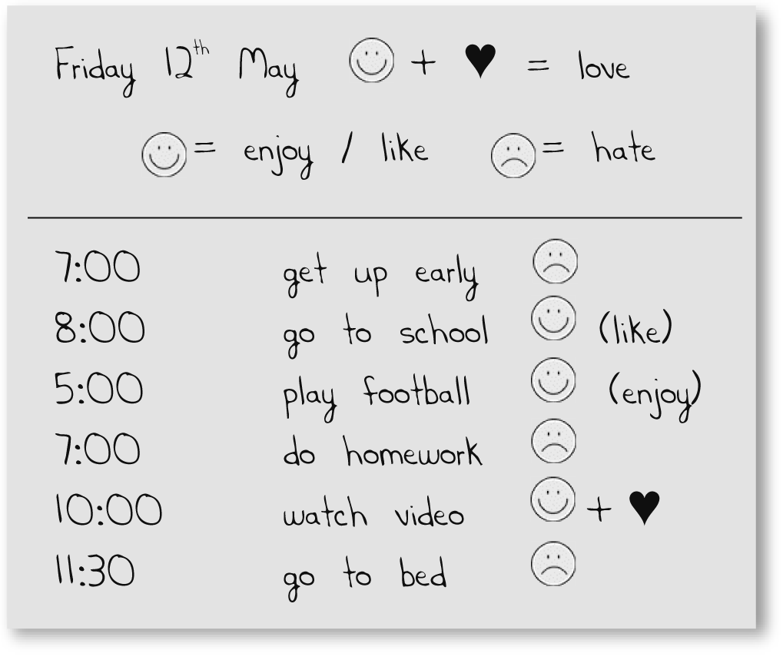
1 Ben hates getting up early.
2
3
4
5
6
UNIT 2

1. What would these people like to do?
1 Peter/go/Italy
Peter would like to go to Italy.
2 Susan/be/singer

3 I/not/fail/exams

4 Malcolm and Tricia/visit/Taj Mahal

5 You/get up/at 5:30 every day/?

6 We/not/live/big city

2. Order the words to make offers. Then match the offers 1-5 with the situations a-f.
1 the/open/I/shall/door/?
Shall I open the door? (c)
2 me/would/wash up/to/like/you/?

3 the/I/phone/shall/answer/?

4 the/like/grass/would/me/you/to/cut/?

5 room/would/me/the/like/tidy/you/to/?

6 letter/I/post/shall/the/?

a The grass is very long.
b There’s a letter on the table.
c A man carrying some bags can’t open the door.
d The room is very untidy.
e The plates are dirty.
f The phone is ringing.

UNIT 3

1. Complete the chart.

Adjective | Comparative | Superlative
long | longer | the longest
big
happy
good
important

2. Complete the sentences with one of the adjectives from exercise 1 in the correct form.
1 The Amazon is the _______________ river in the world.
2 Spain is _______________ than England.
3 I think Liverpool is _______________ than Arsenal, but Manchester United is the _______________ team in the league.
4 The _______________ person in the film is the director.
5 Sheila is the _______________ girl in the class.
UNIT 4

1. What is the past of the verbs in the box? Write them in the correct column.
come feel go have invite know
like speak start walk want work
Irregular past Regular past
1 came 7 _______________
2 _______________ 8 _______________
3 _______________ 9 _______________
4 _______________ 10 _______________
5 _______________ 11 _______________
6 _______________ 12 _______________

2. Rewrite these sentences in the past.
1 He sees his girlfriend all the time.
He saw his girlfriend all the time.
2 Sarah gives her grandma a present.

3 Andy lives with his cousins.

4 William speaks very quietly.

5 Jermaine can play the guitar.

6 Michael wants to be famous.

7 Janet appears on TV.

8 Jack’s son breaks the CD player.

9 Ben buys lots of cassettes.

10 Sally plays the guitar.

UNIT 5

1. Correct these past continuous sentences.
1 They was working hard.
They were working hard.

2 I was eat my lunch.

3 Yesterday we swimming in the sea.

4 Andy were living in Paris.

5 You no were telling the truth.

6 Natasha was don’t sleeping.

7 I’m wasn’t listening to music.

8 He was playing golf?

9 Were watching they the match?

UNIT 6

1. Complete the questions with a verb in the correct form.
1 ‘What about playing football?’ ‘Sorry, I’ve hurt my leg.’

2 ‘How about __________ to the cinema?’ ‘OK. I haven’t been there for two weeks.’

3 ‘What about __________ some orange juice?’ ‘No thanks. I’ve just had a drink.’

4 ‘How about __________ a letter to your cousin?’ ‘There’s no need. I’ve just talked to her on the phone.’

5 ‘What about __________ your homework?’ ‘Oh, Mum! Do I have to?’

2. Complete the conversation with expressions from the box.

enough how many how much too

A: Good morning. Can I help you?
B: Yes. I’d like to buy some sandals. ¹ How much are they?
A: Well that depends on
² ________________________ you want to spend. This pair is not
³ ____________________ expensive.
B: €15! I haven’t got ⁴ ________________ to buy them. That’s
⁵ __________________much money for me.
⁶ ____________________________ other types of sandals have you got?
A: We’ve got lots. How about these?
B: OK. No, they’re not big
⁷ ______________ .

3. Complete the sentences using the first conditional.

- If it rains, we won’t go (go) for a picnic.

- If I get hungry, I ____________ (have) a sandwich.

- If it ____________ (snow), we’ll go skiing.

- If my team scores, they ____________ (win).

5 If Tim ____________ (get up) late, he’ll miss the train.
UNIT 7

1. Complete the conversation with can or can’t.
Sophie: ¹ Can I go to the toilet?
Mr. Hook: No, you ² _____ .
Sophie: Sir, ³ _____ I write with a pencil?
Mr. Hook: No Sophie. I’m afraid you ⁴_____ .

2. Complete the text with have to or don’t
have to.
My mum says that my two brothers and I
¹ have to help with most of the household chores. We ² (no) __________ do everything but, for example, I
³ __________ do the shopping with my parents and my big brother, Dave,
⁴ __________ carry the bags into the house from the car. My little brother ⁵ (no) __________ do much because he’s very young, but he ⁶ __________ keep his bedroom tidy. I also ⁷ __________ help my mum with the cooking. Dave ⁸ (no) __________ do that because he
⁹ __________ lay the table. My dad
¹⁰ __________ clear the table and do the washing up after lunch and dinner. When I think about it, my mum is very clever. She ¹¹ (no) __________ do much at all!

3. Write complete sentences using should or shouldn’t.
1 clean/teeth/after/dinner
You should clean your teeth after dinner.
2 wash/hands/before/lunch

3 talk/food/in/mouth

4 eat/three/meals/day

5 throw/bread

6 use/knife/eat/soup

7 clear/table/after/eating

8 leave/table/before/others

UNIT 8

1. Correct these future arrangements.
1 I’ll going to my friend’s house.
I’m going to my friend’s house.
2 She’ll meeting me at 10 o’clock.

3 We’re play football this afternoon.

4 Jim’s to working at the weekend.

5 Grandma coming to stay tomorrow.

6 They’re no starting work on Monday.

7 I’m taking not my next holidays in Italy.

8 Lisa arriving is tonight?

9 We having lunch in the pizza restaurant on Saturday?

2. Complete the predictions about your life using will or won’t. Use the words from the list if you want to.
married live abroad girl/boyfriend
retired job work as a …
dead! speak great English start playing …

- When I’m 20 I’ll have a job.

2 When I’m 18 _____________________

3 When I’m 20 _____________________

- When I’m 25 _____________________

5 When I’m 35 _____________________

6 When I’m 50 _____________________

- When I’m 65 _____________________

- When I’m 80 _____________________

9 When I’m 99 _____________________

3. Look at Greg’s plans for the weekend and write sentences.
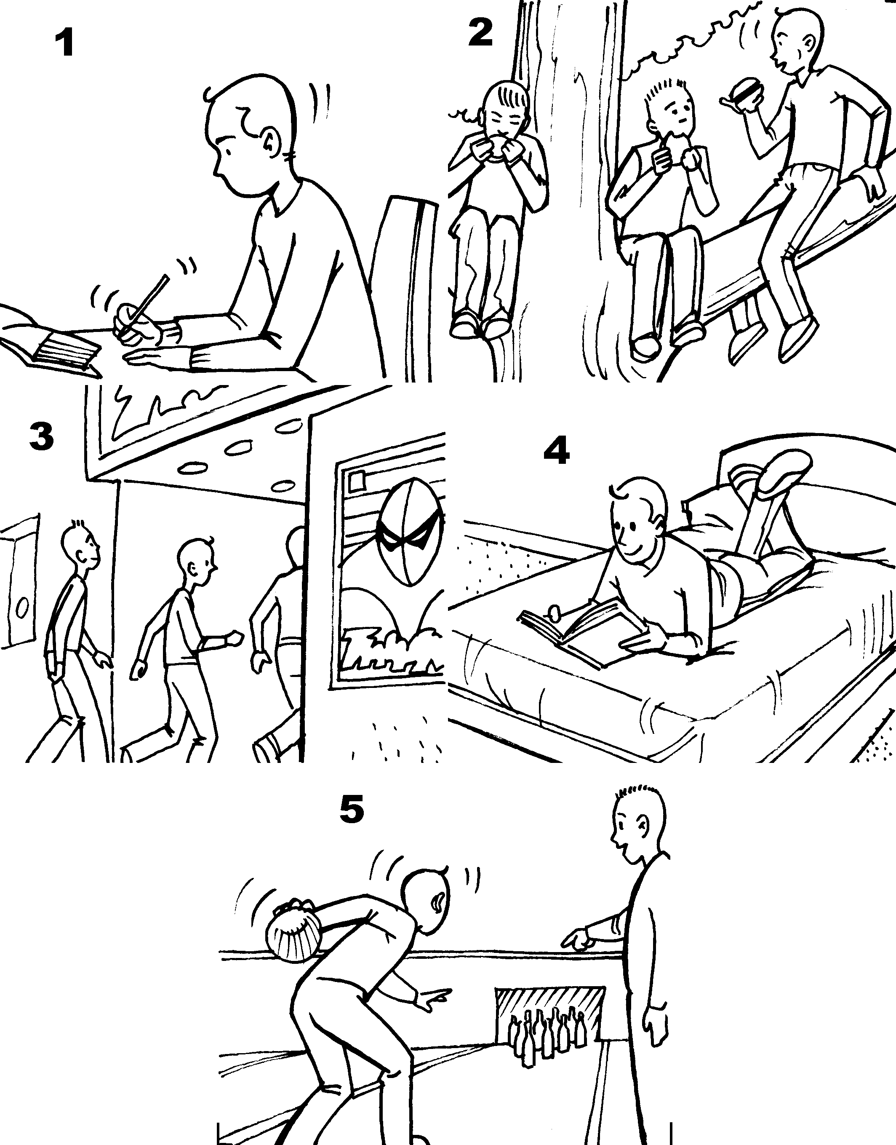

- On Saturday morning Greg’s going to do his homework.

2 On Saturday at lunchtime

3 On Saturday afternoon

4 On Saturday evening

5 On Sunday morning

4. Correct the sentences if necessary.
1 I’m buying the CD next week.
OK.

2 We watching a music video tonight.

3 Sting are making a new record next month.

4 Britney Spears is changing her image.

5 They’s not listening to the concert on the radio later.

6 The band isn’t going on tour in the summer.

7 U2 are play in a football stadium.

8 I choosing the music for the party.

9 Christina Aguilera isn’t singing at the festival.
VOCABULARY

ADVERBS OF MANNER

1. Complete the sentences with an adverb from the box.
badly carefully cheaply clearly
confidently crazily easily happily
quietly sadly

- He relaxed in front of the audience and talked confidently about his project.

- A teacher has to speak _________________ so that his students understand.

- Martina lost the tennis match because she played _________________ .

- You don’t spend much money if you buy things _________________ .

- She watched _________________ as her boyfriend left on the train.

- She picked up the baby _____________ because he was so small.

- The soldiers made no sound and moved _________________ because the enemy was near.

- He smiled and told her _________________ about his good news.

- He had no problems with the test and passed it _________________ .

10 He jumped around and danced _________to the music.

2. Write the adverbs for these adjectives. (Note: not all of them end in -ly.)

1 surprising surprisingly
2 fast
3 slow
4 cold
5 hard
6 good

3. Now complete the sentences with the adverbs.
1 Gemma won the race because she ran very fast.

2 Snails move very _________________ .

- The small man was
strong.

- Andy worked _______________ all day.

5 Liverpool won the cup because they
played very .

6 She didn’t like Tom and she looked at him

FOOD

1. Match the food and drink with a type of container or quantity and its picture.
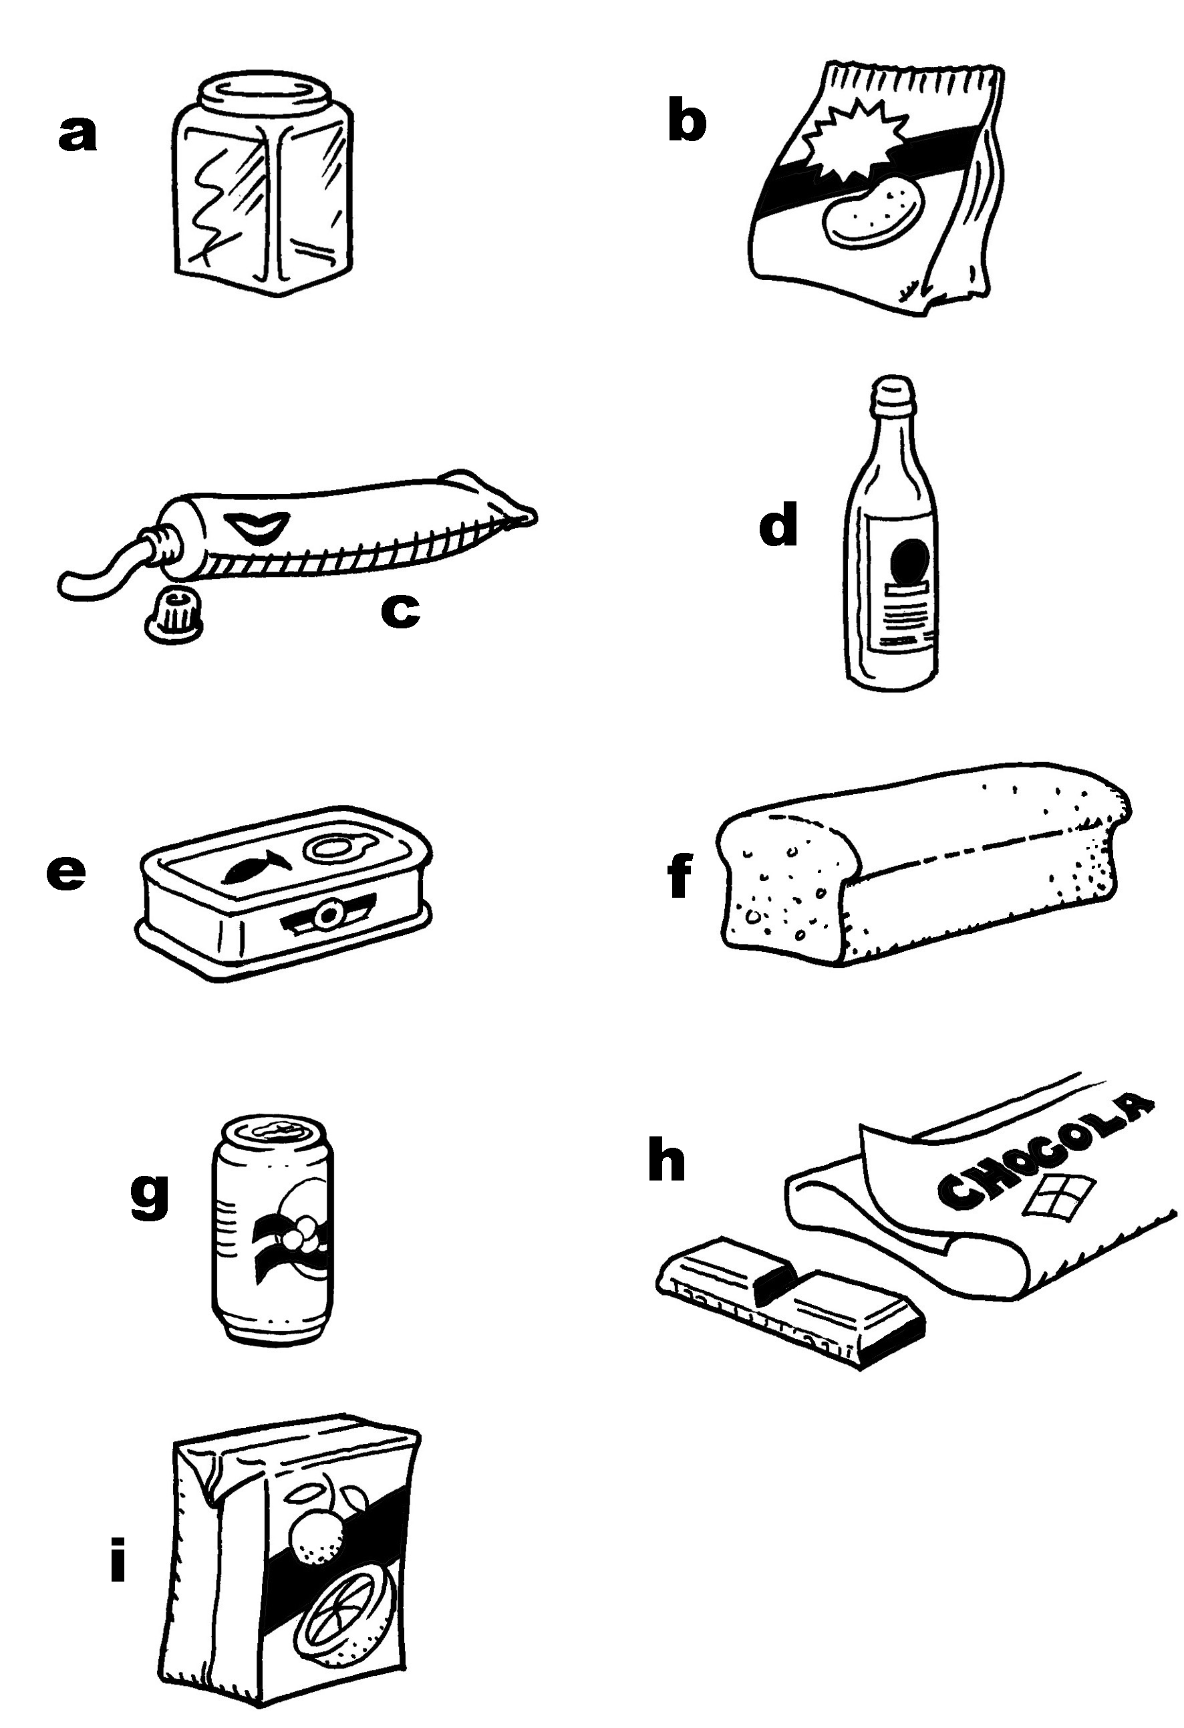

1 a tin of chocolate ___
2 a packet of water ___
3 a tube of sardines e
4 a loaf of crisps ___
5 a carton of toothpaste ___
6 a bar of soft drink ___
7 a bottle of orange juice ___
8 a can of honey ___
9 a jar of bread ___

2. Order the letters to form verbs connected with food and cooking.
1 tearg grate
2 liob __________
3 ciles __________
4 keab __________
5 lilrg __________
6 yfr __________
7 nurb __________
8 sarot __________
9 samh __________
10 marblesc __________
11 poch __________

3. Circle the participles of the verbs from exercise 2.
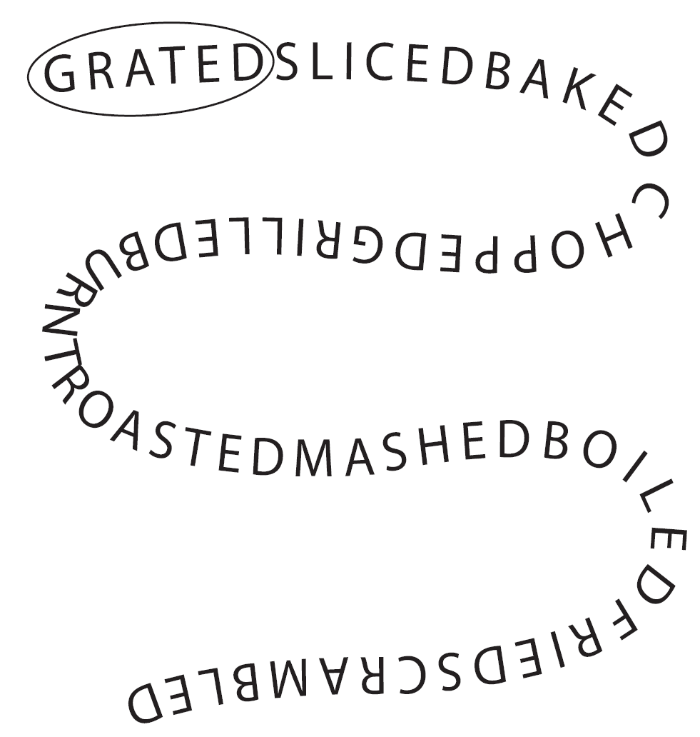

4. Write the possible ways to prepare these foods.
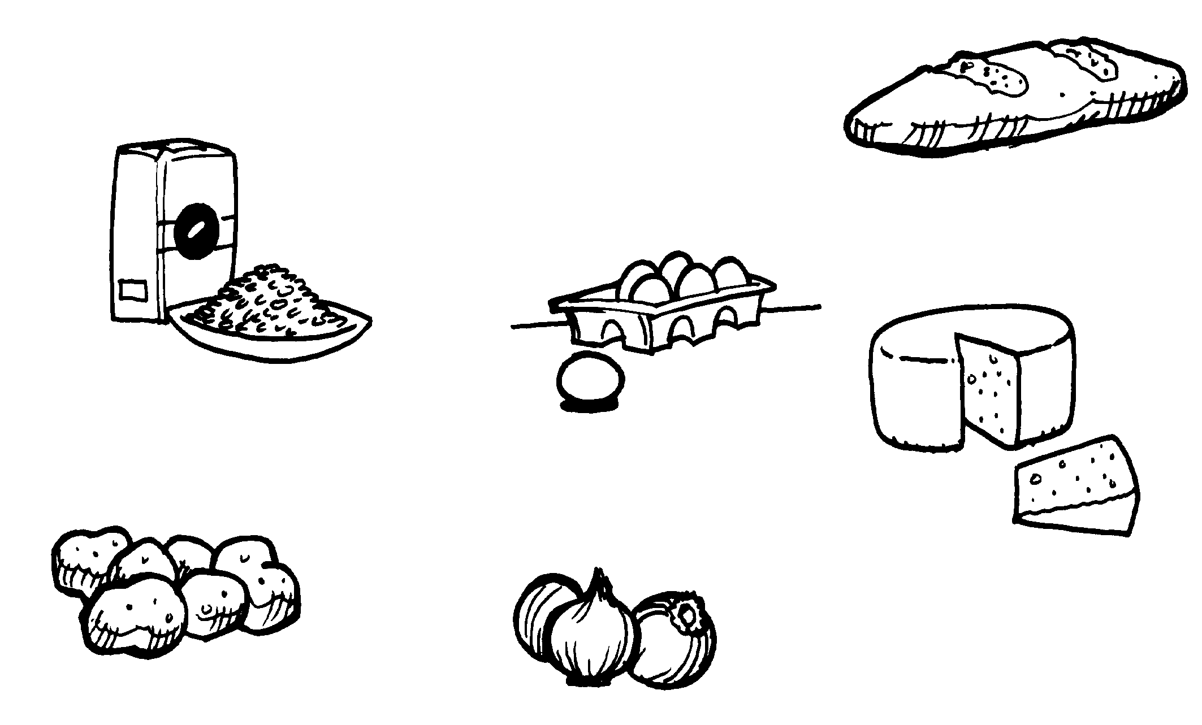

1 eggs: fried, boiled, scrambled, poached
2 cheese:

3 bread:

4 onions:

5 rice:

6 potatoes:

FREE-TIMES ACTIVITIES

1. Choose an activity from the list and write it next to the related word.

cooking
dancing
painting
playing a musical instrument
playing football/tennis/basketball
reading
surfing the Internet

1 goal playing football
2 food ________________
3 piano ________________
4 website ________________
5 book ________________
6 music ________________
7 racket ________________
8 paintbrush ________________
9 basket ________________

2. Match the pictures with the activities.
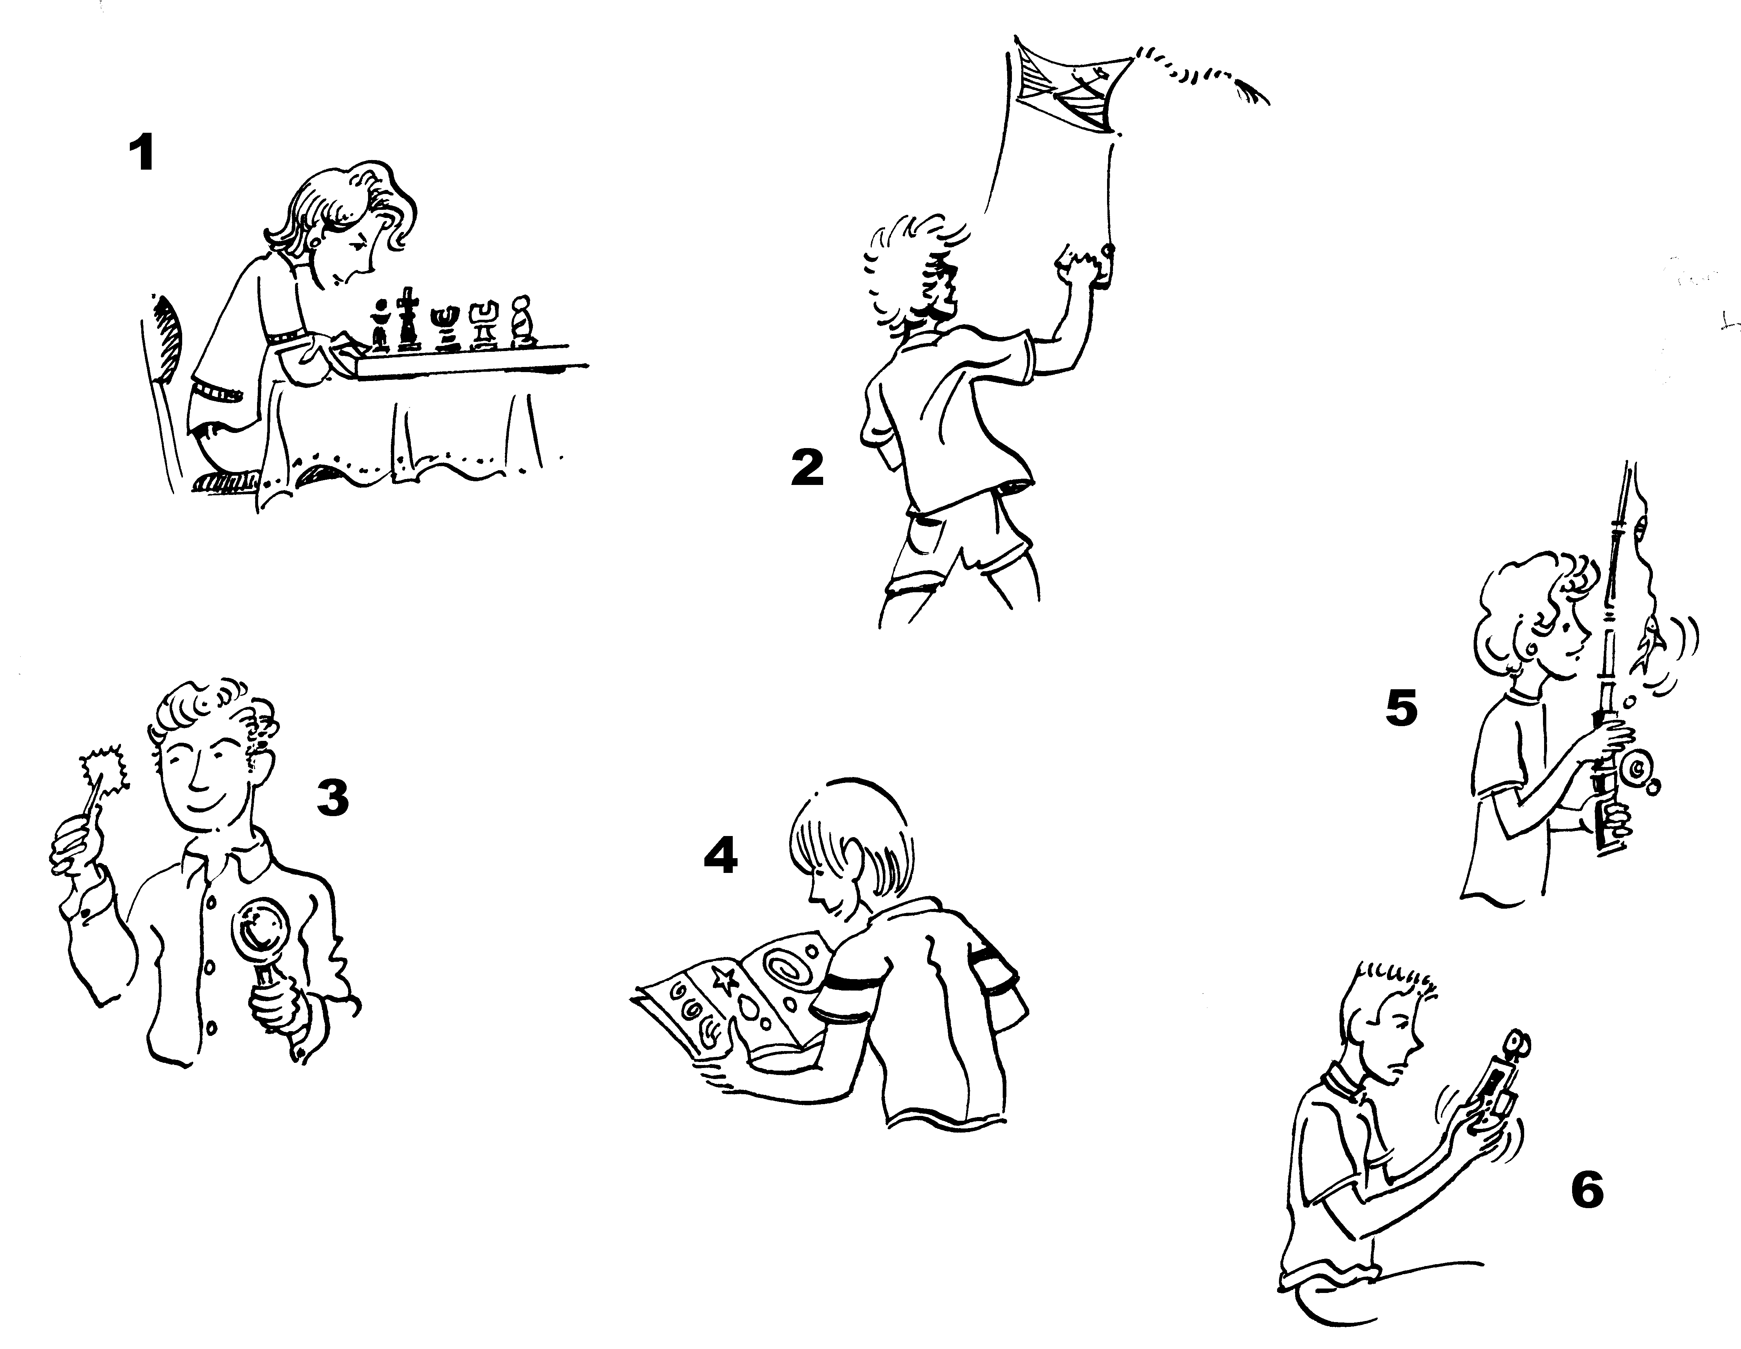

a astronomy
b fishing
c flying a kite
d playing chess
e playing video games
f stamp collecting

1 playing chess
2
3
4
5
6

3. Match the verbs (1-7) with the people and things (a-g). Then complete the sentences.
1  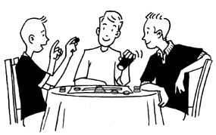 | 2  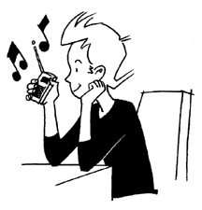
3  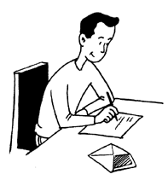 | 4  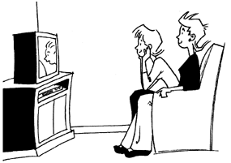
5  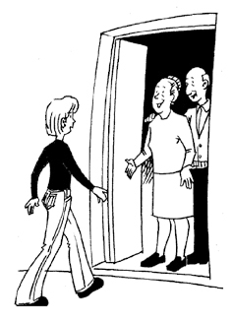 | 6  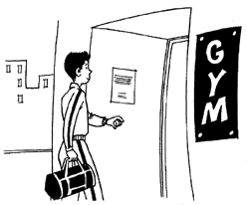
7
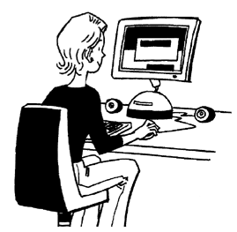

1 play a grandparents
2 listen to b a letter
3 write c the Internet
4 watch d a board game
5 visit e the gym
6 go to f music on the radio
7 surf g a film on TV

1 They’re playing a board game.
2 She
3 He
4 They
5 She
6 He
7 She

LIKES AND DISLIKES

1. Write sentences about your likes and dislikes using words from the two boxes.
like don’t like don’t mind
hate enjoy love

get up early swim do my homework
sleep play tennis eat chocolate
tidy my room study cook

1 I enjoy sleeping.
2
3
4
5
6
7
8
9

2. Complete the sentences with the correct form of the verb.
1 I’d love (see) to see you tonight.
2 I wouldn’t mind (speak) speaking in English today.
3 I’d like (have) __________ a drink.

4 She’d hate (get up) __________ early tomorrow.
5 I’d enjoy (sit) __________ on the beach right now.
6 I’d prefer (eat) __________ pizza than a hamburger.
7 I wouldn’t mind (see) __________ the film again.
8 I’d love (win) __________ the lottery.

3. Write your own sentences about these specific situations.
1 have an exam today
I’d hate to have an exam today.
2 buy a motorbike

3 tidy my room now

4 eat some chocolate at the moment

5 go to the cinema tonight

6 wash my parents’ car today

7 meet a film star

MUSIC

1. Match to form types of music.
1 heavy -no heavy metal
2 ja hop _____________
3 reg metal _____________
4 class -sa _____________
5 hip -era _____________
6 fo -zz _____________
7 in -ical _____________
8 sal -lk _____________
9 tech -gae _____________
10 op -die _____________

2. Look at the parts of musical equipment. What are they and who uses them? Choose a word from each box.

keyboard  guitar  microphone  drum stick | guitarist  drummer  singer  keyboard player

1  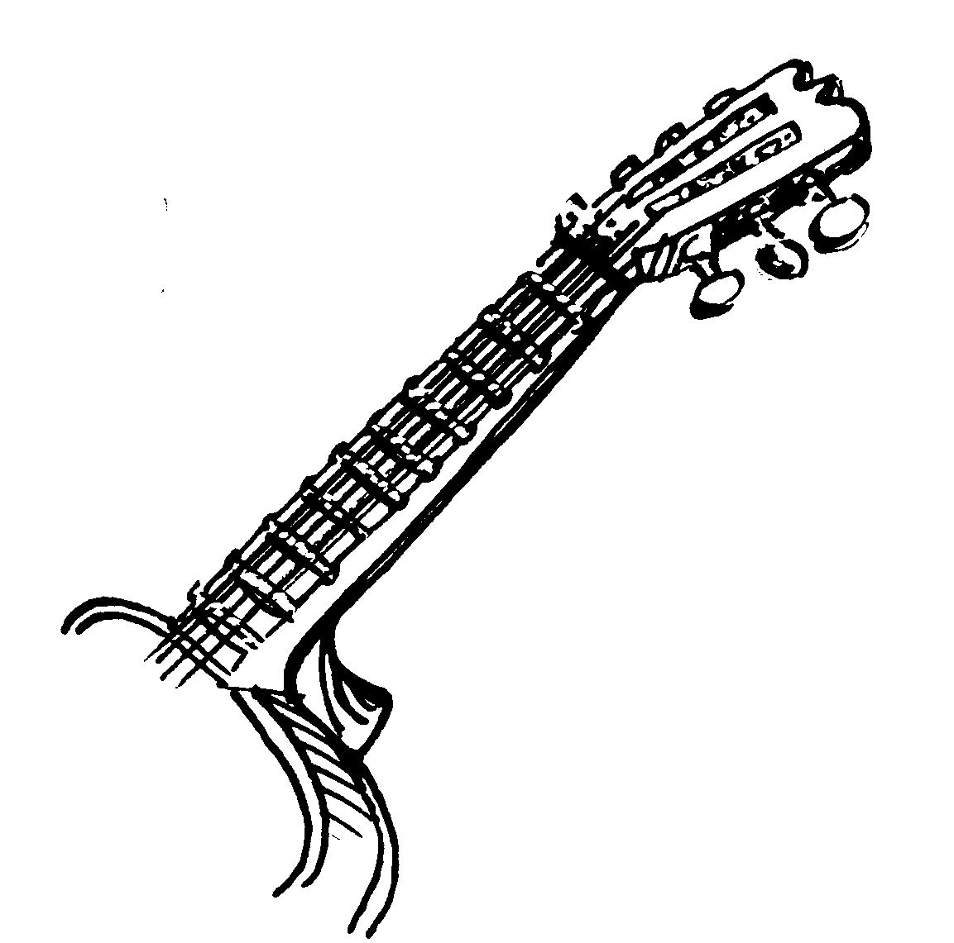 | 2  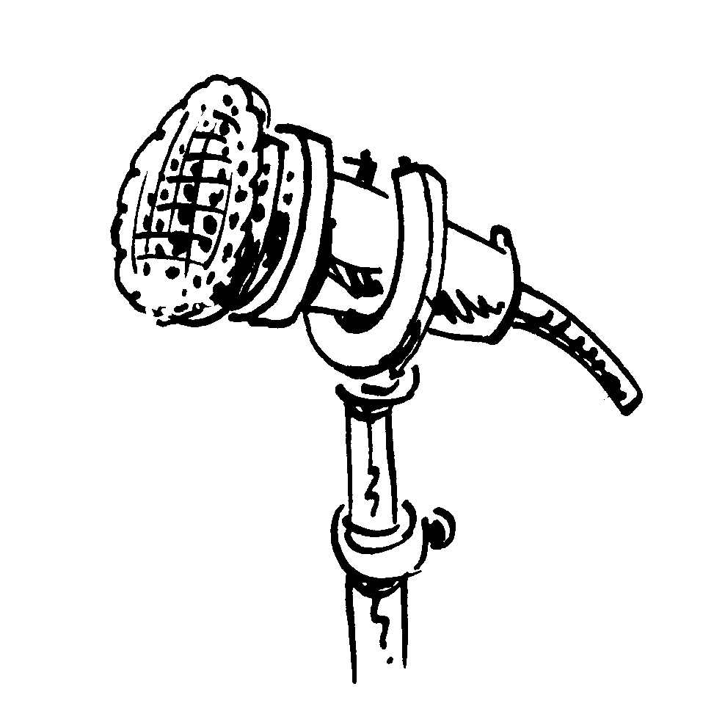
3  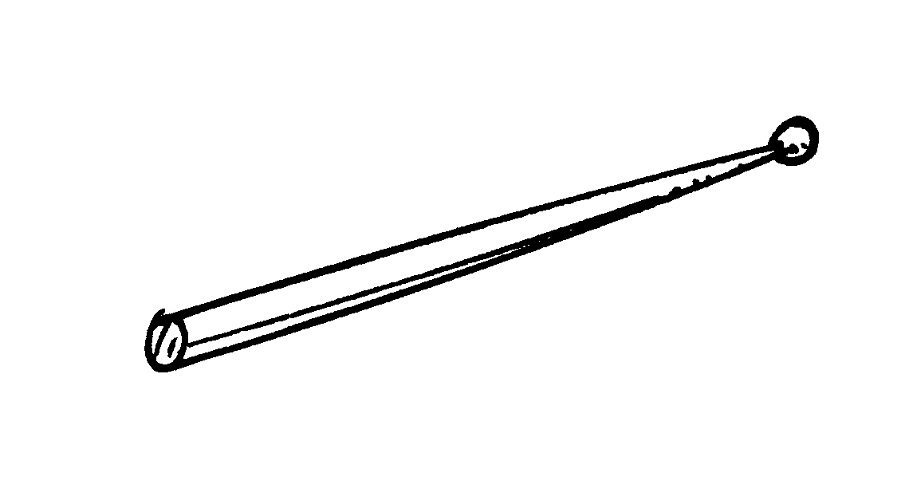 | 4  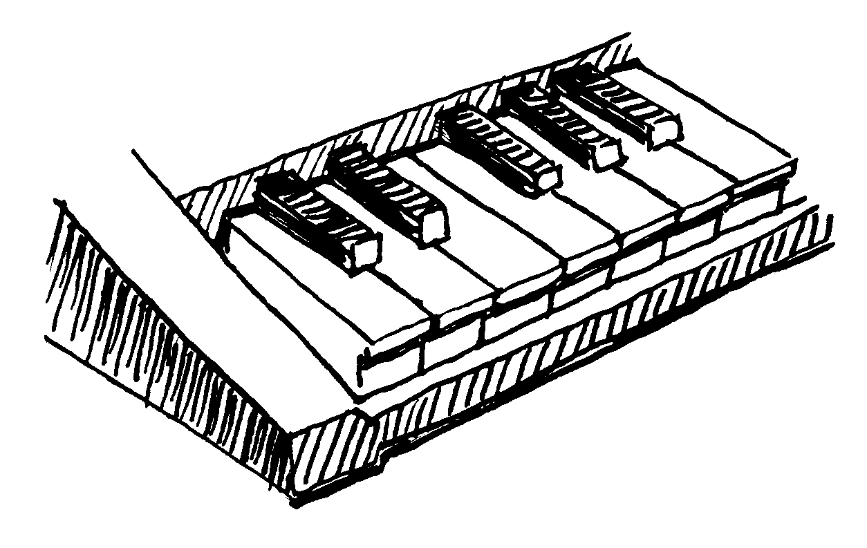
1 guitar – guitarist
2
3
4

3. Write the letters in the correct order to form words related to music.
1 getsa stage 6 vecor ________
2 deario __________ 7 bedut ________
3 ggi __________ 8 thi ________
4 recone __________ 9 thasrc ________
5 rotu __________ 10 kunp ________

4. Match words from exercise 3 with the definitions.
1 a new version of an old song

2 a series of concerts around the country or world

3 a hard and aggressive type of music

4 a person who works with a band at a concert

5 a band’s first record

6 a colloquial word for ‘concert’

7 a record that lots of people buy

8 an extra song at the end of a concert

9 the part of a concert hall where the band plays

10 a numerical list of today’s most popular records

5. Find eight types of music and seven more musicians in the word search and write them below.
P I A N I S T N E W A T
R A E E C O M P O S E R
U J L F O R Y A V I P I
Y C A X U J F Y C U H T
R O C K N R O L L C B R
E N L X T A L J A X R H
A D P L R M K M S E W I
F U U E Y N F E S H A P
M C P D I B U S I O H H
C T H B V E T E C H N O
A O F O I J A C A S R P
S R E L O C O P L E D A
S C E L L I S T E Z R Q
D H O A I X I C B W U T
A C E L N I N T L T M P
N Z T P I H G W U E M I
C X B L S O E I E D E A
E G U I T A R I S T R J

6. Order the letters to form types of music.
1 lokf folk
2 selub
3 kroc’n’lorl
4 salclicas
5 conthe
6 pih poh
7 roncytu
8 cedna
9 agareg

Types of music | Musicians
 | conductor

OCCUPATIONS

1. Rearrange the letters to form jobs.
1 sub verdir bus driver
2 chearitct
3 tomrecup remapgrom
4 trocod
5 redlibu
6 horpgatehorp
7 tve
8 tarhece
9 macniche
10 awrite
11 serreshirad

2. Complete the crossword with some of the words from exercise 1.
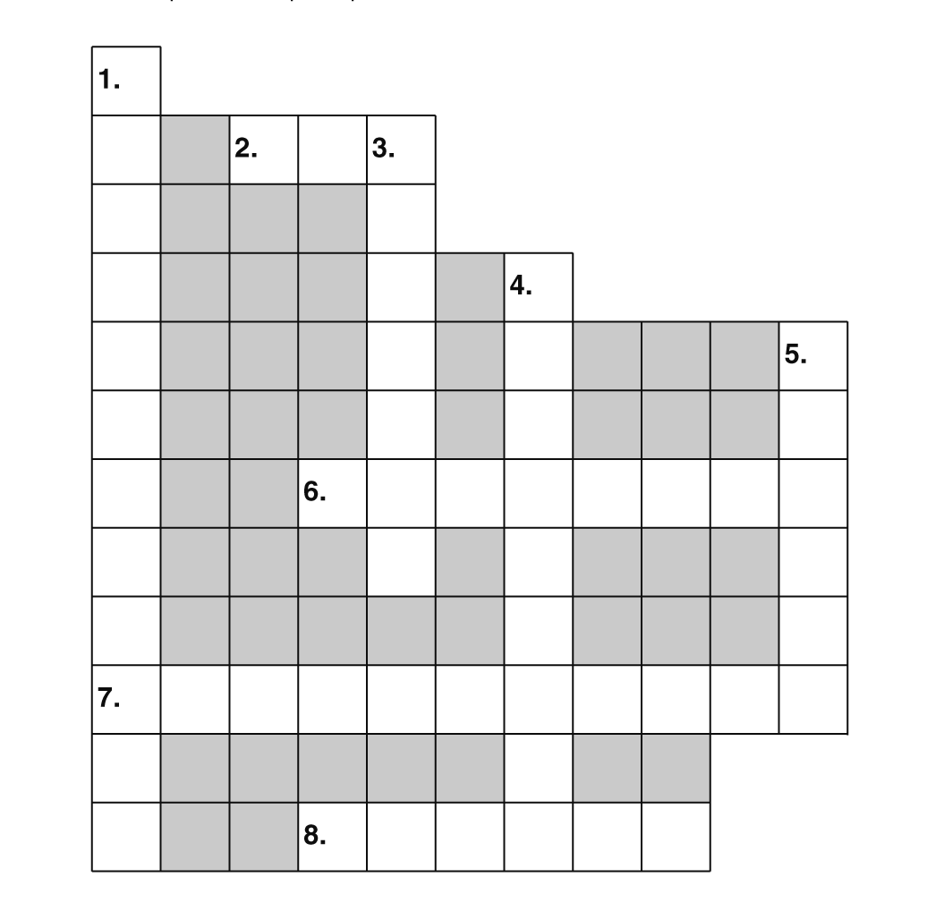

Across:
2 works with sick animals
6 repairs cars
7 cuts your hair
8 brings you food in a restaurant
Down:
1 uses a camera
3 educates people
4 designs buildings
5 helps sick people

3. Match the jobs in the box with the pictures.
astronaut butcher gardener
nurse office worker pilot
receptionist traffic warden
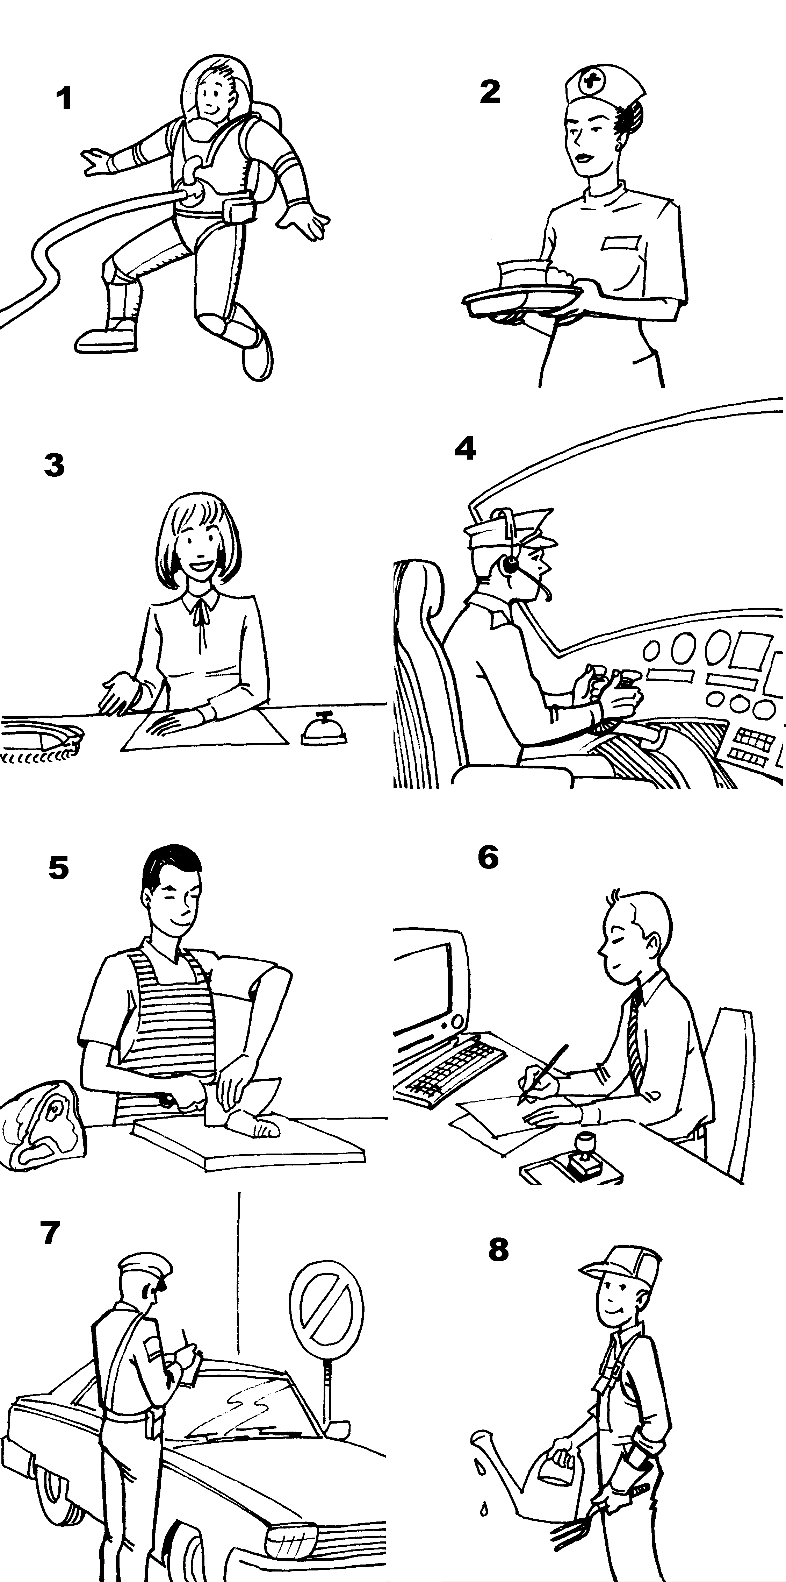

1 astronaut 5 _______________
2 _______________ 6 _______________
3 _______________ 7 _______________
4 _______________ 8 _______________
4. Match the words to form more professions.
1 police reader policeman
2 bank assistant
3 pop man
4 lorry ranger
5 news star
6 zoo manager
7 shop keeper
8 park driver

JOBS FORMED WITH -ER, -R, -OR

1. Write the job for each person/picture.
1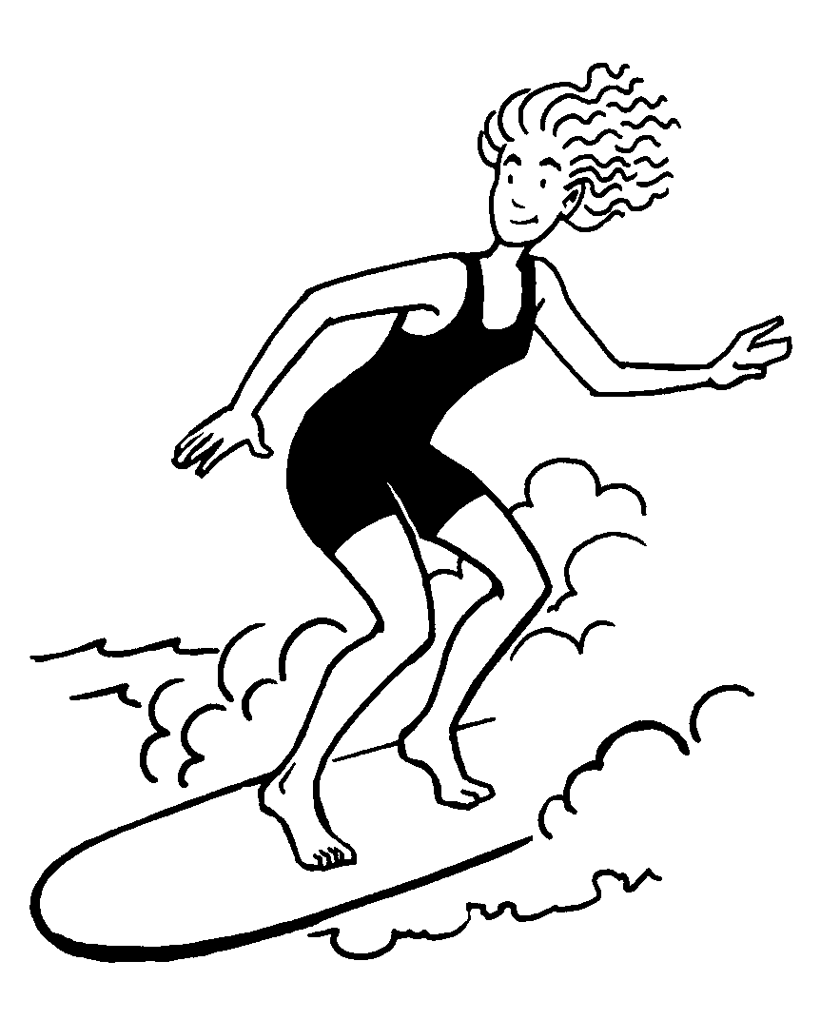 | 2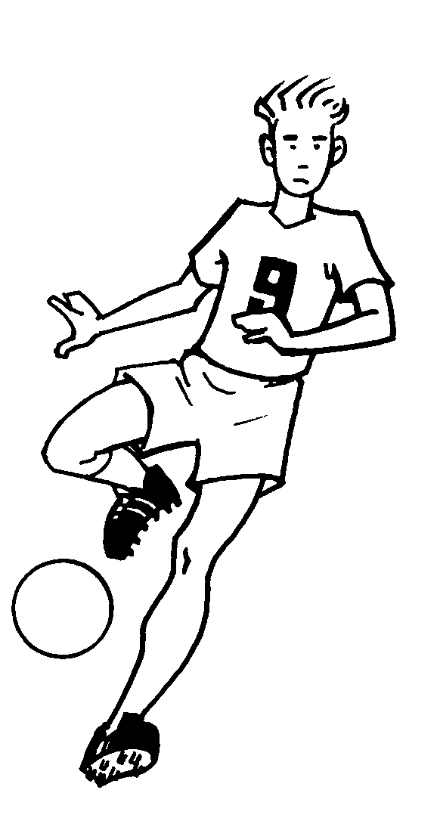
3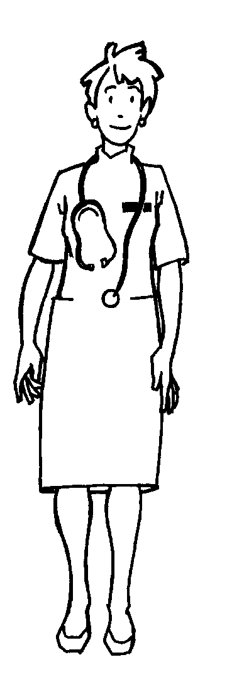 | 4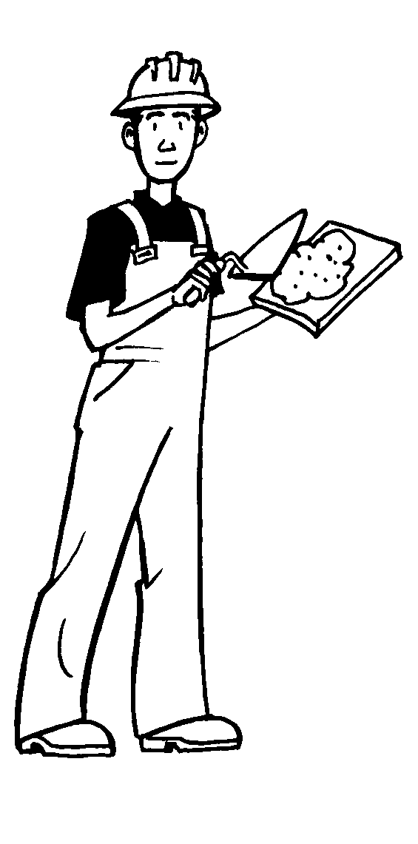
5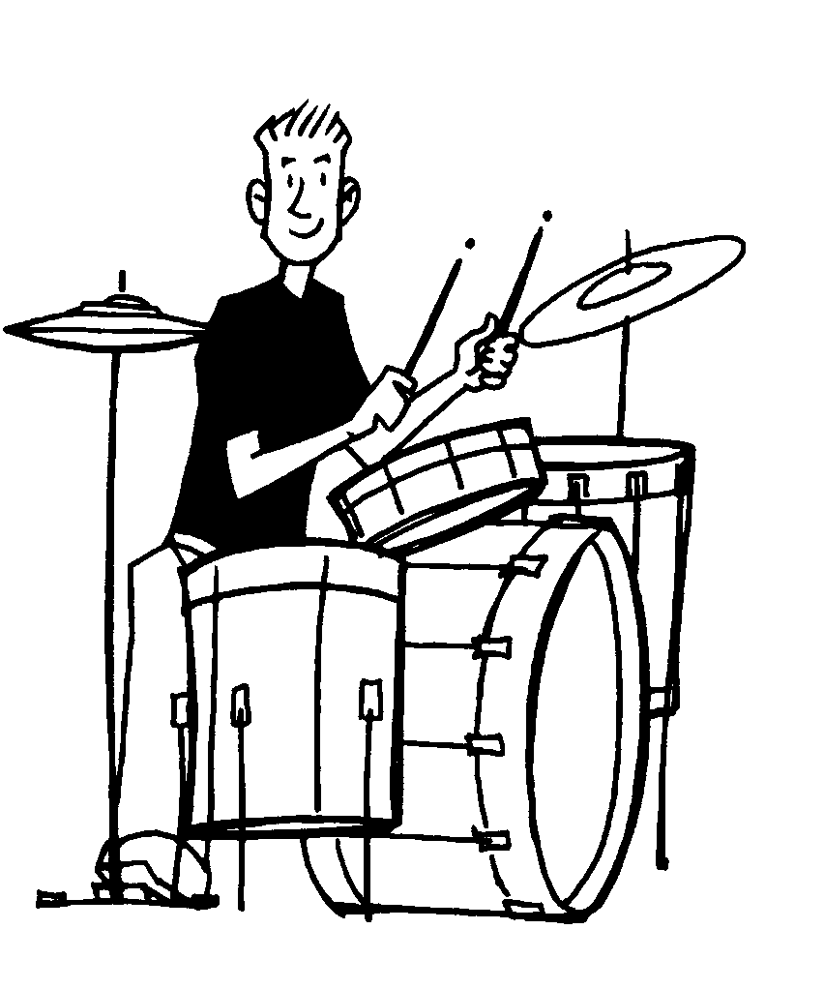 | 6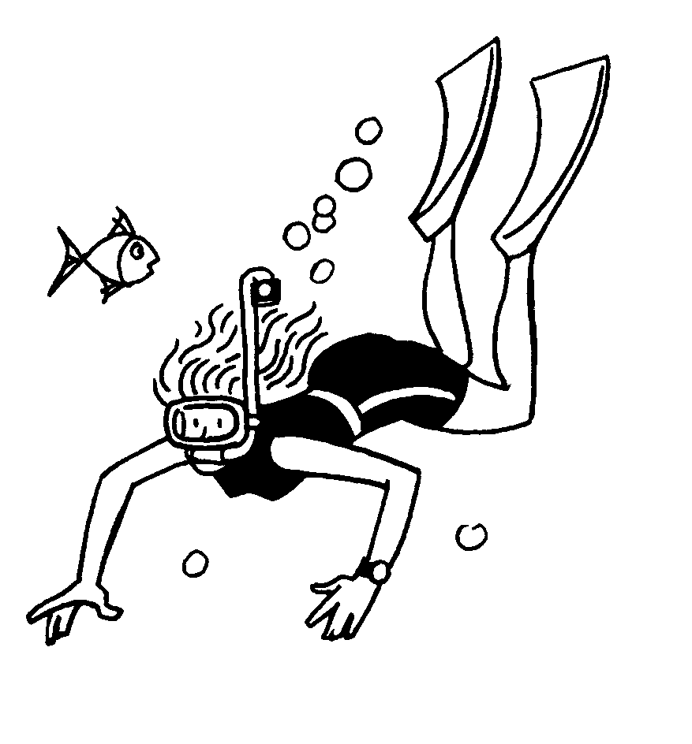
7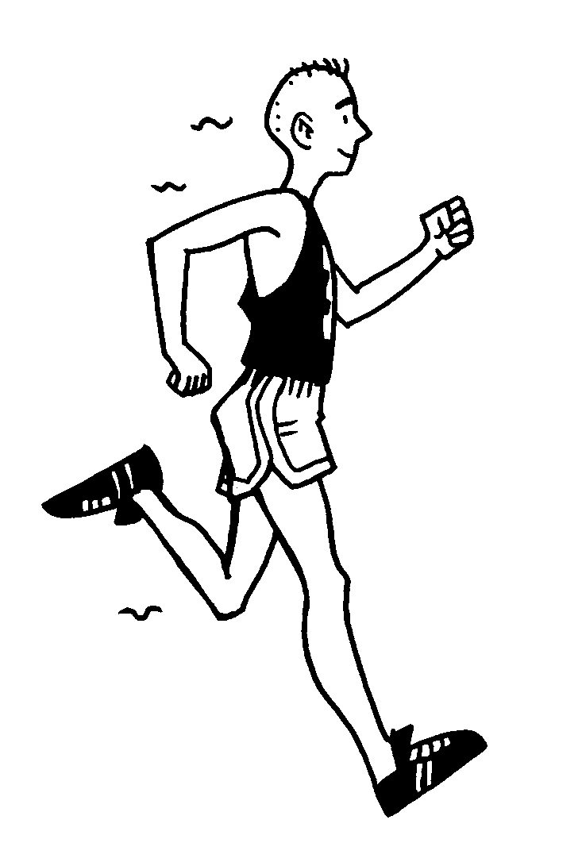 | 8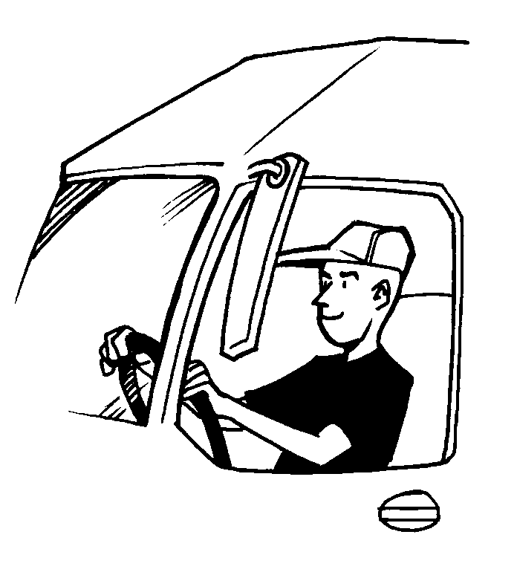
9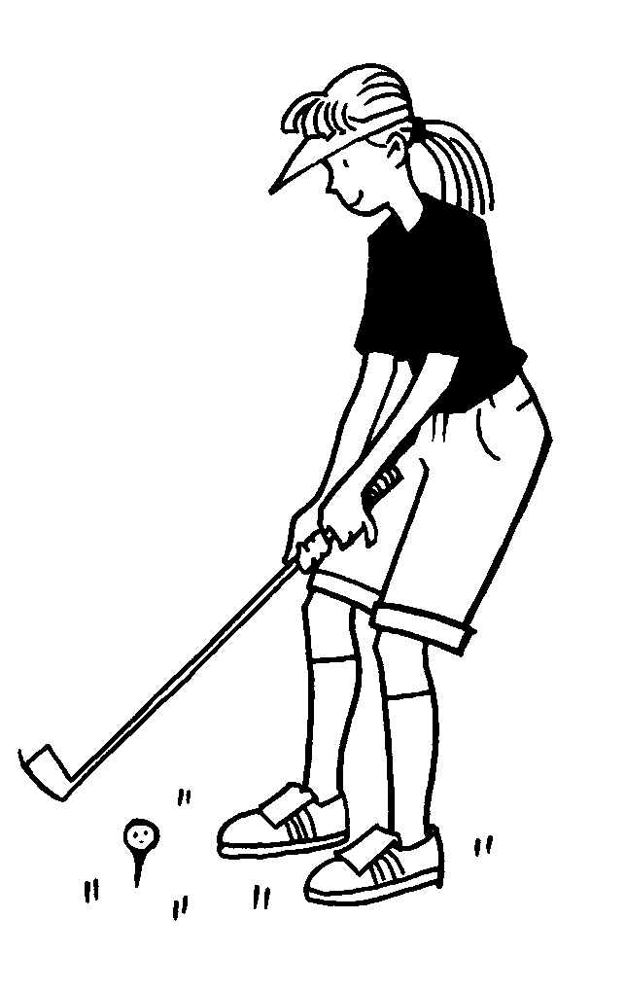 | 10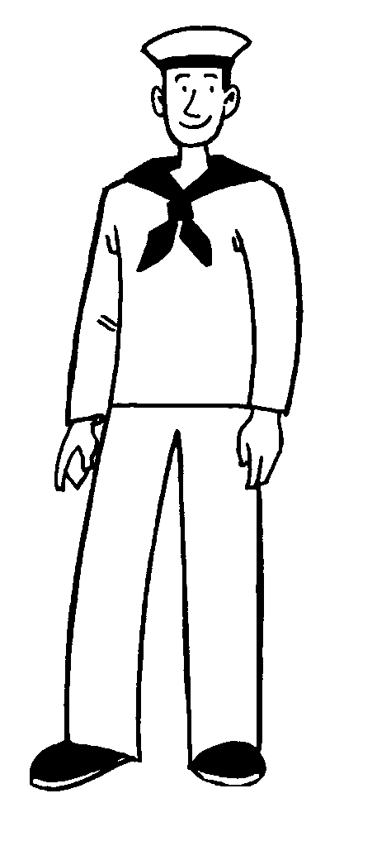
11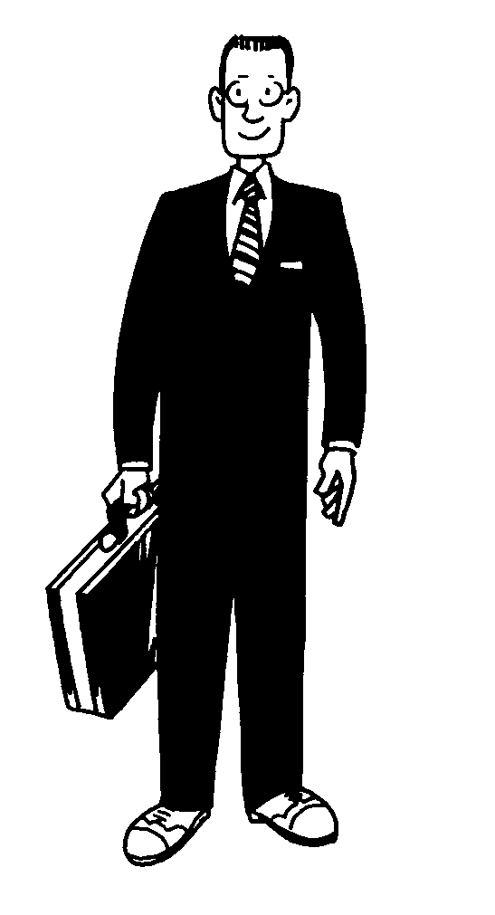 | 12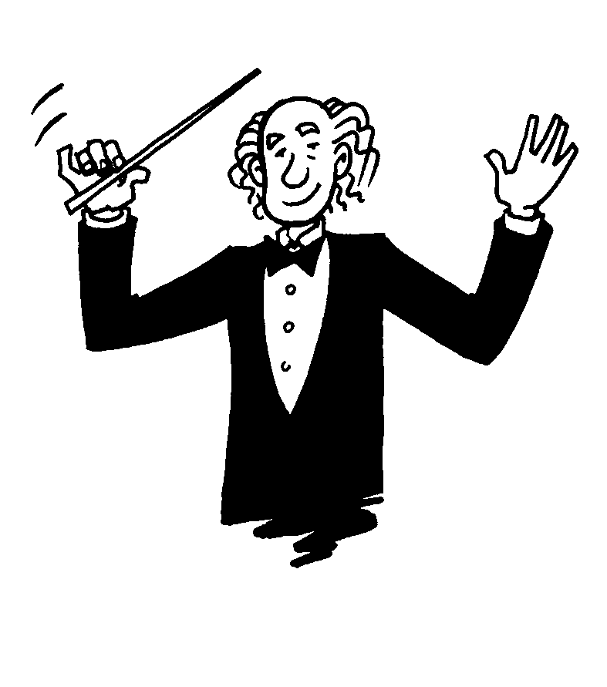

1 surfer 7 ______________
2 _______________ 8 ______________
3 _______________ 9 ______________
4 _______________ 10 ______________
5 _______________ 11 ______________
6 _______________ 12 ______________

2. Write definitions for the jobs in exercise 1.
1 A surfer goes surfing.
2
3
4
5
6
7
8
9
10
11
12

3. Answer the questions.
1 Who dances ballet?
A ballet dancer
2 Who drives a bus?

3 Who plays basketball?

4 Who swims?

5 Who climbs rocks?

6 Who inspects tickets?

7 Who drives a taxi?

8 Who robs banks?

9 Who teaches science?

VERBS: serve, repair, design, look after, sell, fly, help
1. Find seven verbs in the word search.
L L E S R E O A I
F O P T R S E L D
Y V O H E L G L E
F R E K P L E H S
E L P E A E R V I
G B Y H I F P T G
N G S E R J T G N
D H F S E R V E W
S R Y L V R E O R

1
2
3
4
5
6
7

2. Use the verbs from the word search to write sentences using the words below.
1 shop assistant/customers
A shop assistant serves customers.
2 pilot/plane

3 web designer/web page

4 mechanic/cars

5 chemist/medicine

6 nurse/patients

7 vet/animals

WORD-BUILDING FROM DIFFERENT PARTS OF SPEECH

1. Write the names of the jobs or objects under the pictures using words derived from the verbs in the box.
build explore farm paint
sing heat hunt

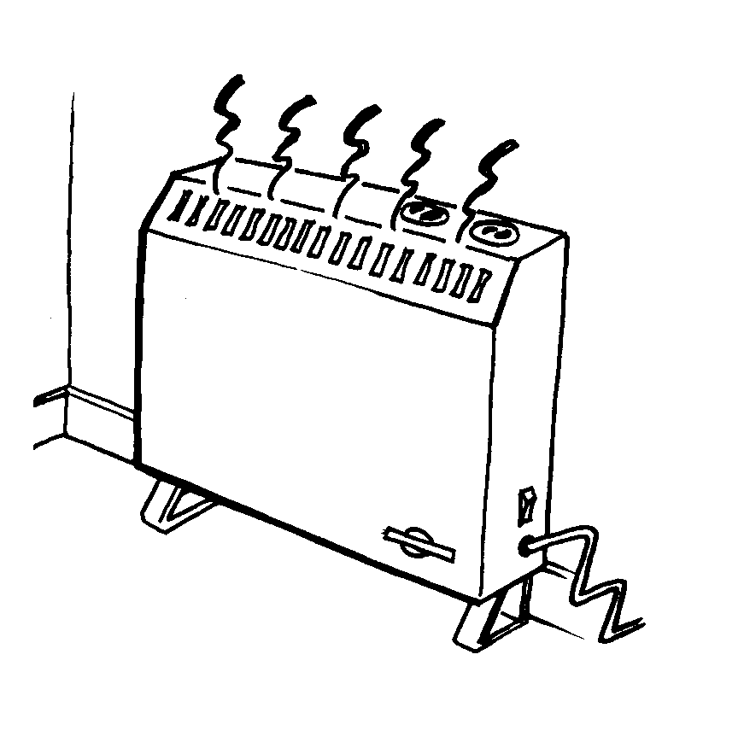  1 heater | 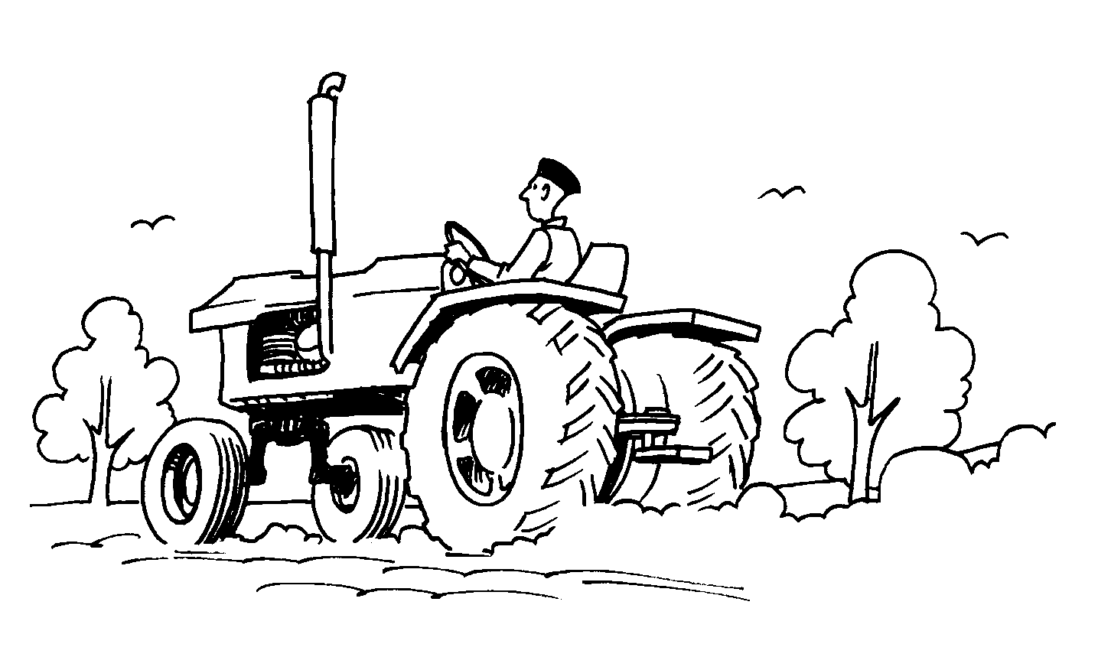  2 ________________
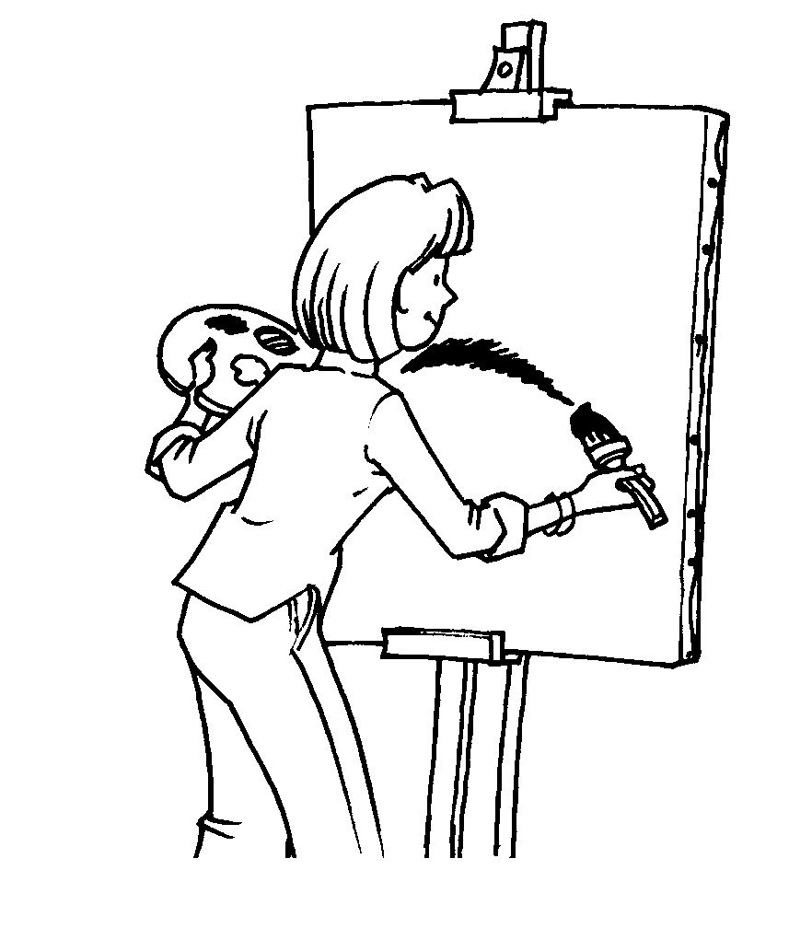  3 _________________ | 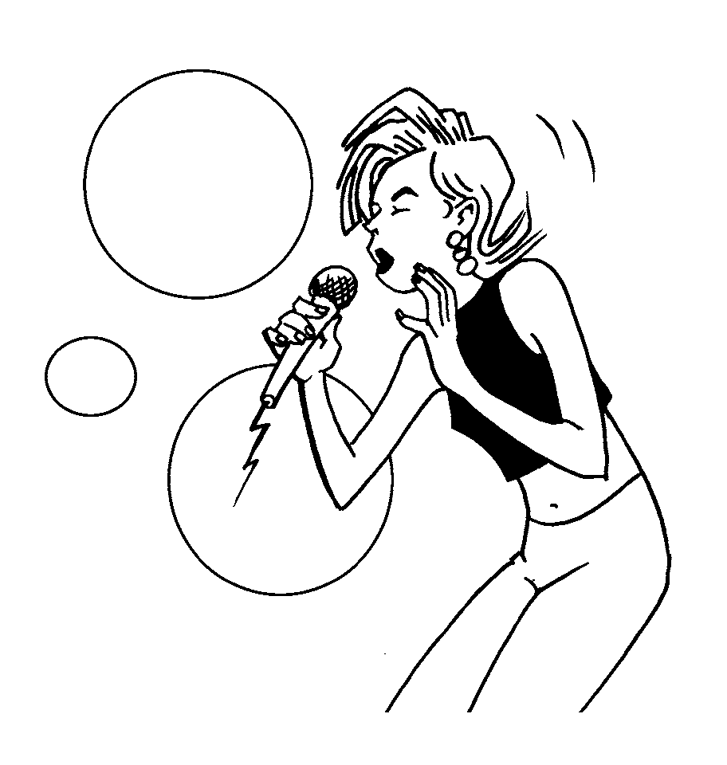  4 ________________
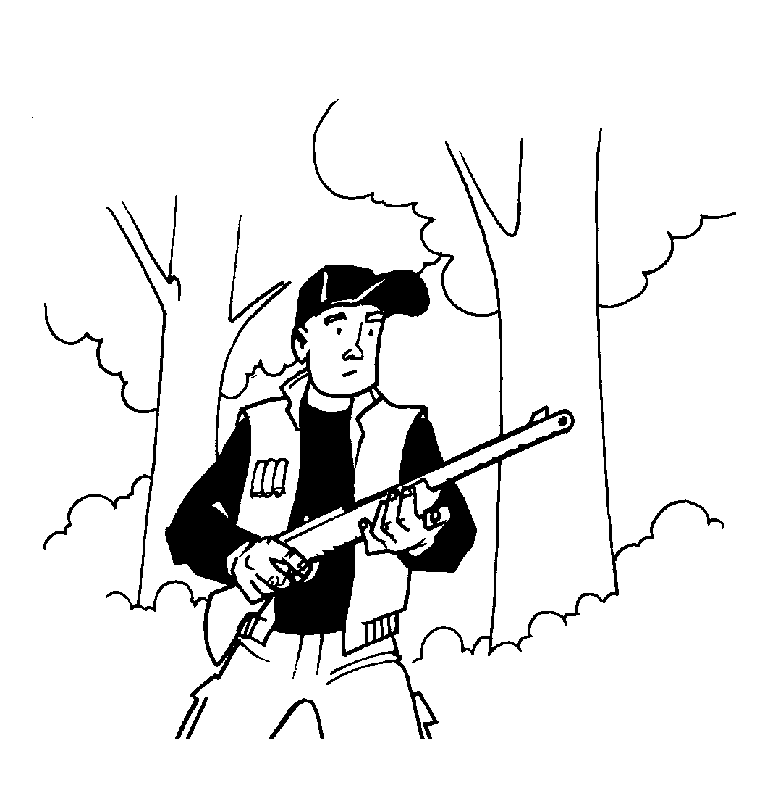  5 _________________ | 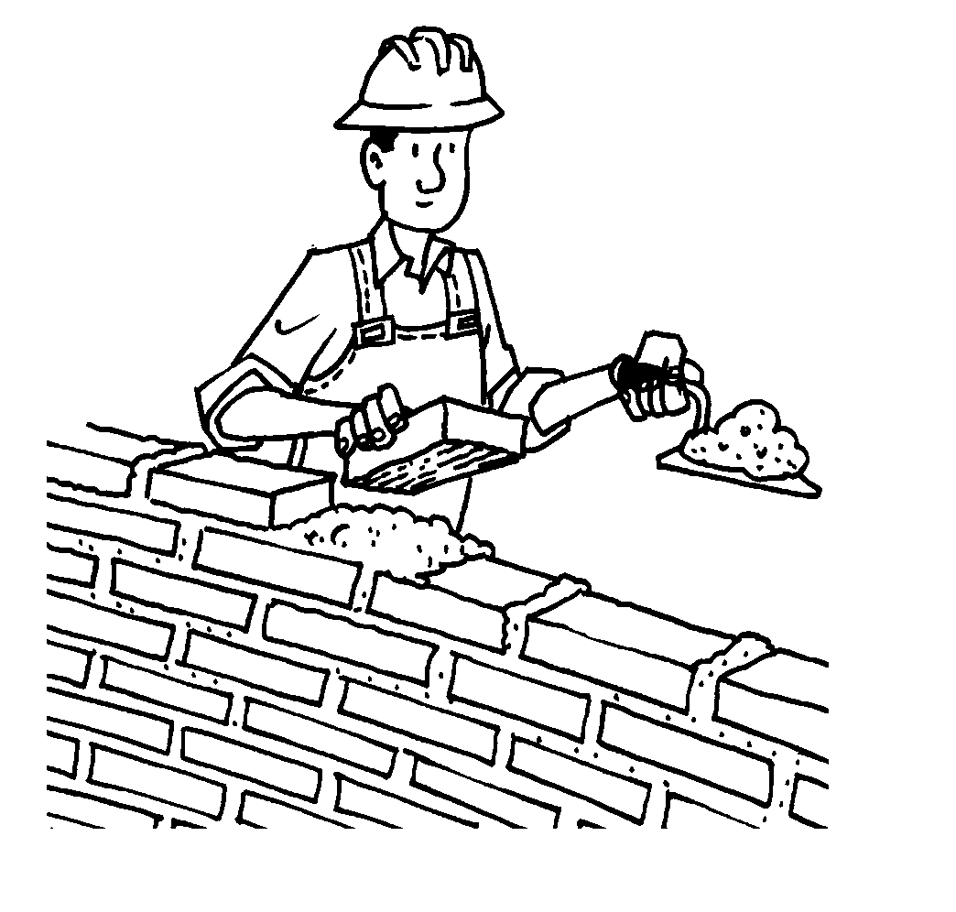  6 ________________
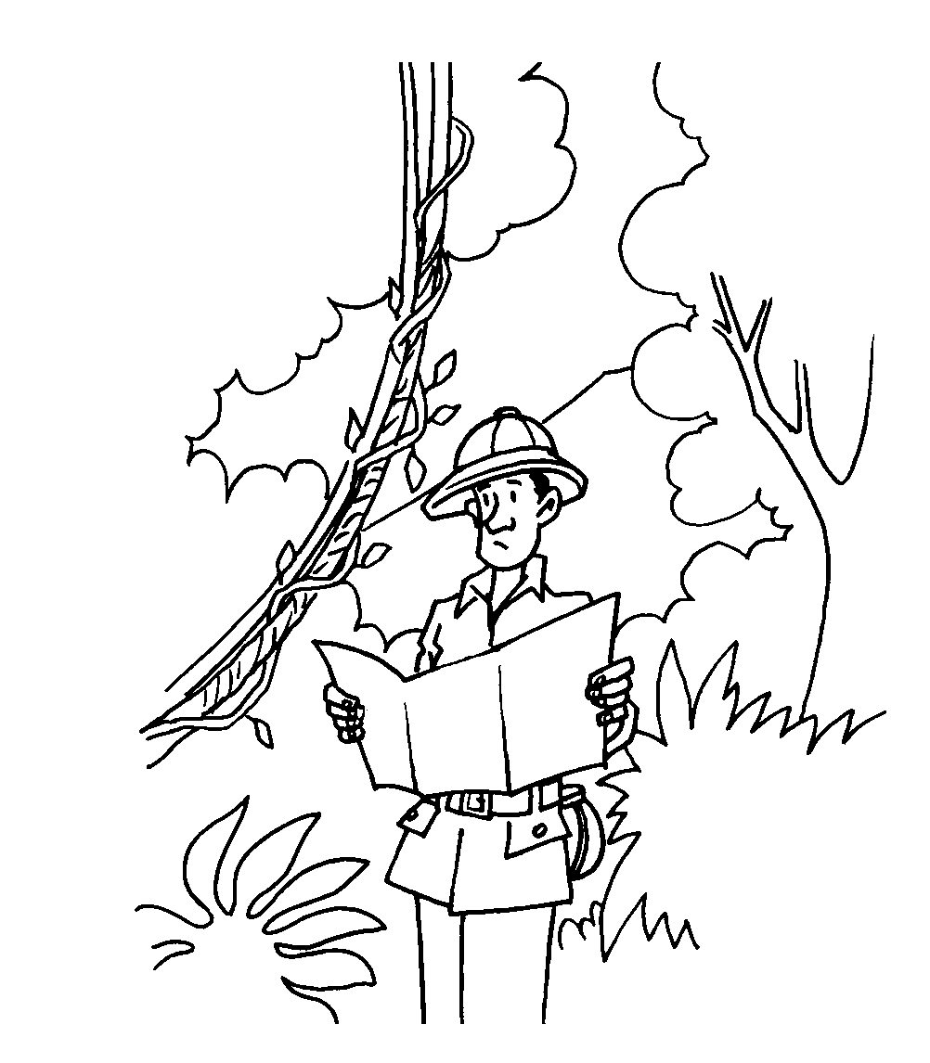
7 _________________

2. Write the activities done by the people and objects from exercise 1.
1 heating
2
3
4
5
6
7

3. Complete the sentences with the nouns and verbs from exercises 1 and 2.
1 The hunter killed three birds and two rabbits.
2 Do you _______________ your pictures or do you draw them?
3 It’s cold in here. Can you turn the _______________ on?
4 Kylie Minogue used to be my favourite _______________ .
5 I’m against _______________ . Killing animals for sport is wrong.
6 My dad’s a _______________ . He constructed that library.
7 I’m studying agriculture because I think _______________ is important.
8 Let’s go and _______________ that old house.
9 The _______________ Picasso was born in Malaga.

WORD-BUILDING FROM VERBS
OF EMOTION

1. Complete the sentences by changing the verb of emotion in brackets into an adjective with -ing, an adjective with -ed, or a noun.
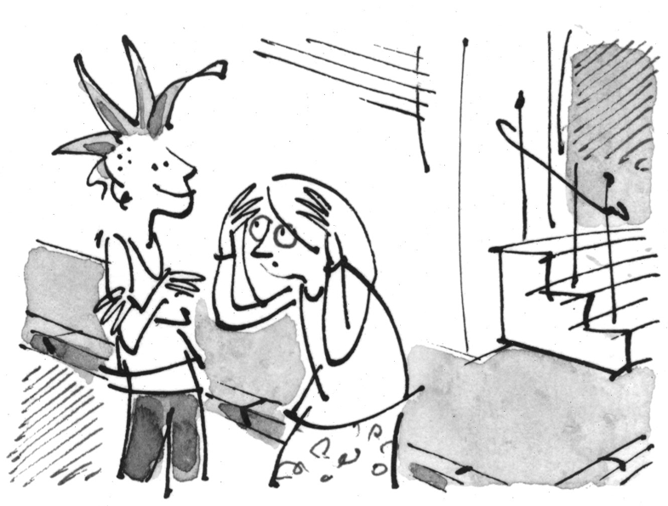
(to shock)
1 Her new hair-style shocked me.
2 It was shocking!
3 It was a shock to see her.

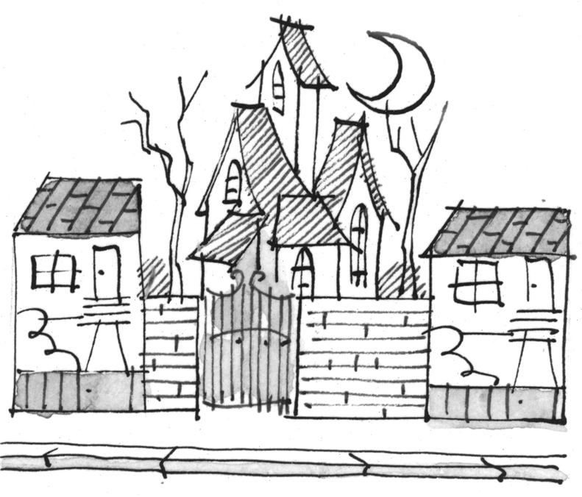
(to frighten)
4 The old house is very .
5 I am too __________ to go inside it.
6 Every time I walk past it I get a .

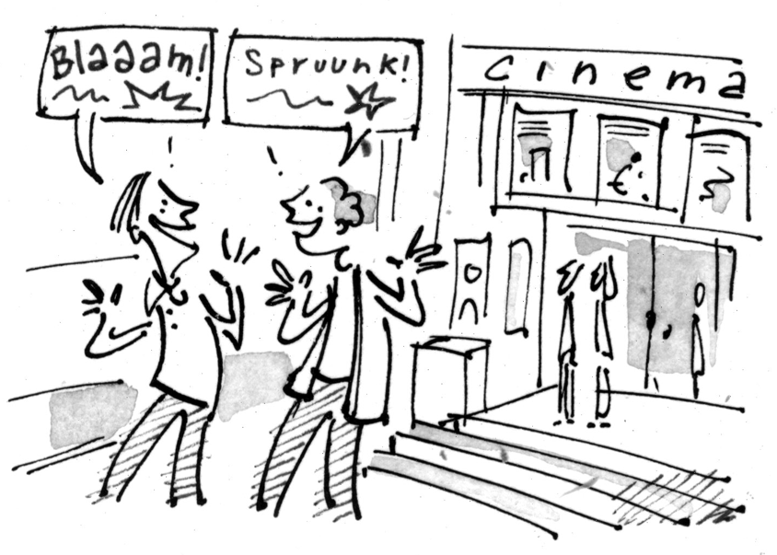
(to amaze)
7 The film’s special effects were .
8 We were .
9 We watched in .

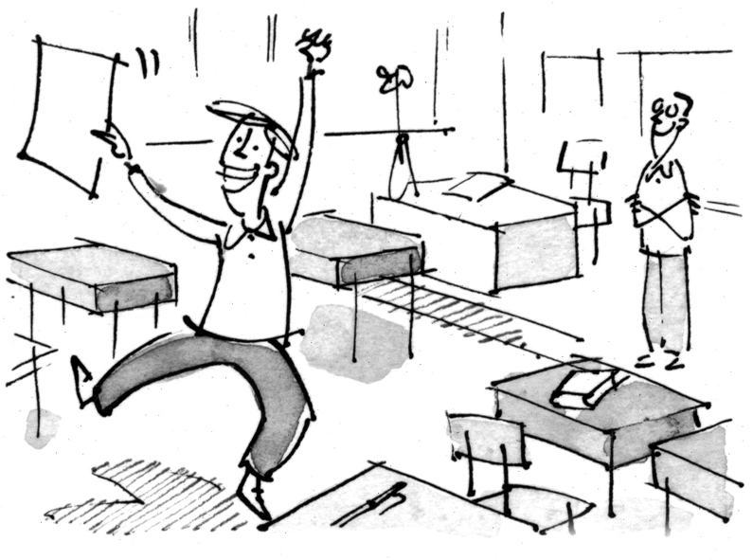
(to surprise)
10 My test results were a great .
11 I was very .
12 The results were __________ for me and my teacher!

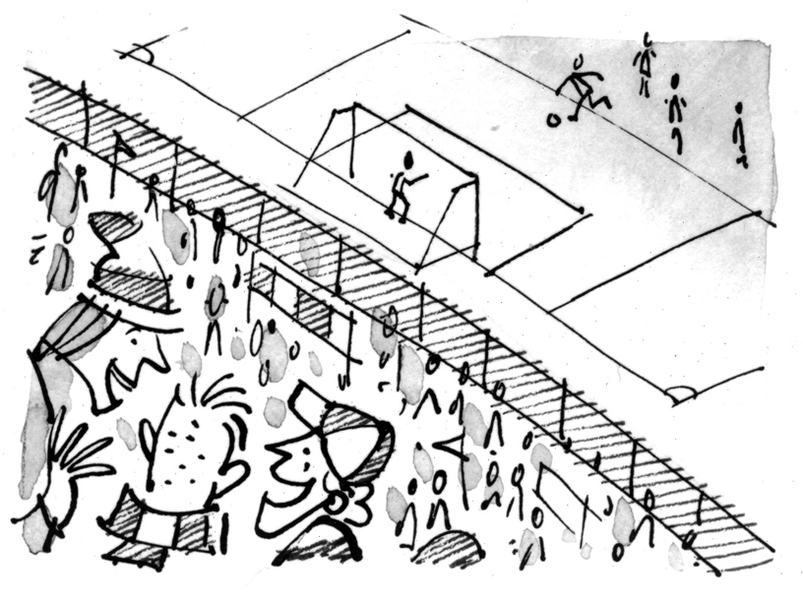
(to excite)
13 The game was very .
14 I felt very .
15 The stadium was full of !

